Feast Freedom

Feast Freedom is a platform which can be used to connect consumers who are looking for home made food, to homemade service providers who cook the food and provide delivery or pickup.

## Project Specifications:

This project will allow the user to register a kitchen and thereafter offer a menu with a variety of options. It will allow, once registered through user detailed information, to then assign specific information as it pertains to the registered kitchen. Such as day worked, time, menu and image just to name a few. Finally the user will be allowed to save or cancel his changes.

## Database Design

[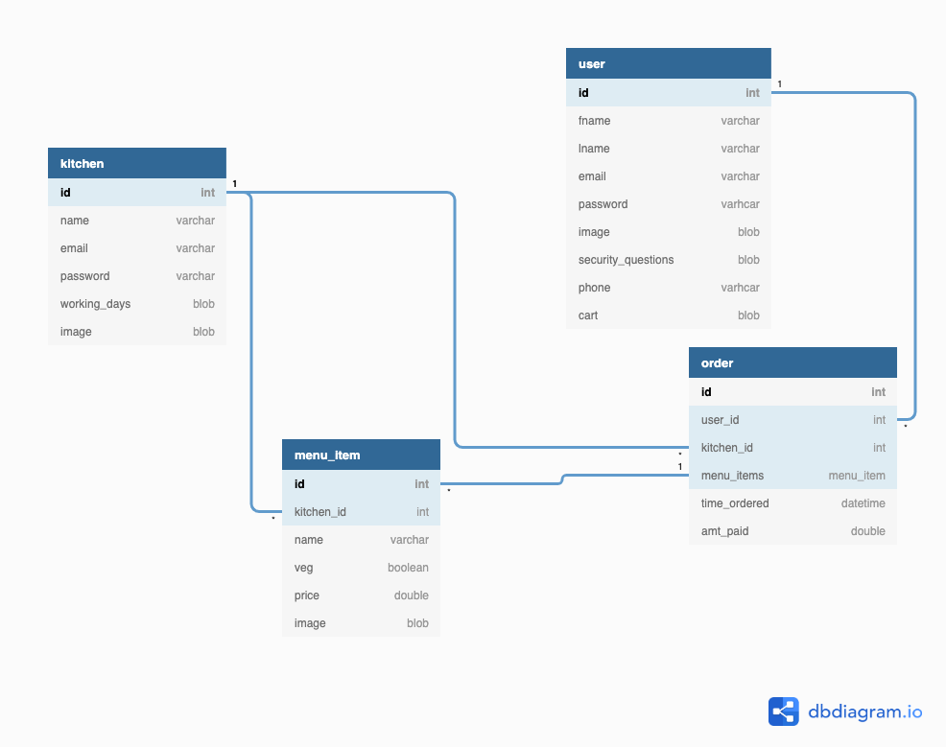](https://dbdiagram.io/d/6011962380d742080a3818ae)

## Software Specifications

* Backend: Spring Boot
* ORM frameworks: Data JPA
* Database: Mysql RDS
* Testing: Junit, Mockito
* DNS: Route 53
* Cloud: Linux EC2 Servers, S3, RDS, lambda
* Cloud services such as IAM,S3,Route 53,RDS,VPC etc
* Security: Spring Security.
* Session management using Spring security
* Version Control: GitHub
* UI: thymeleaf / CSS, maybe ReactCI/CD tools: Jenkins

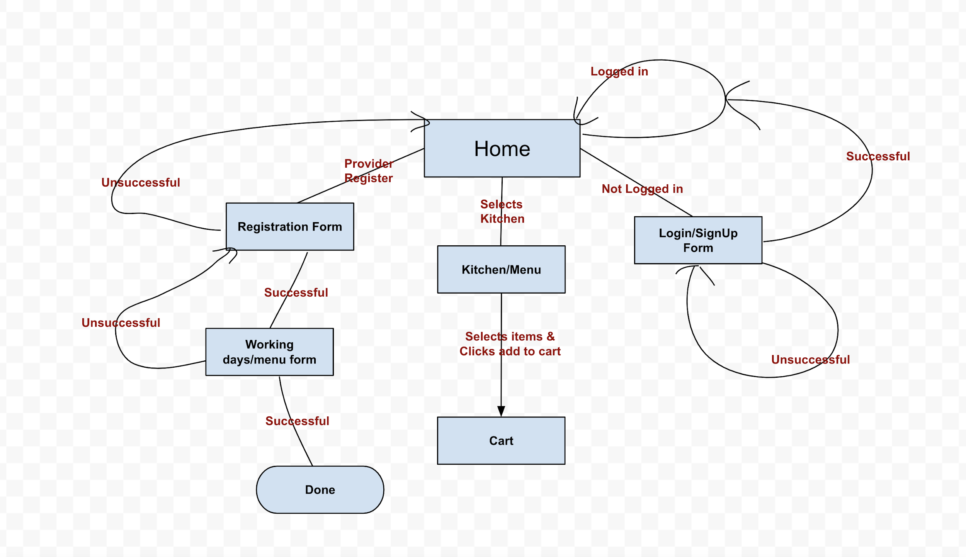

Time lines?